**WRITTEN AND ORAL – AUXILIARIES**

**MUST**: it indicates deduction or formal obligation.

* **You must be John. Your brother told me good things about you.**
* **Kids must not stay in this area.**

**SHOULD**: it indicates an action is prudent or recommendation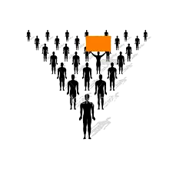

* **You should study for your exam.**
* **Bob shouldn’t drink that much.**

**CAN**: it indicates possibility.

* **I can only leave the company after 6:00pm.**
* **Kelly couldn’t come to the party because she is sick.**

**MAY**: it indicates high probability. It can also indicate permission.

* **You may find excellent material on that website.**
* **May I help you?**

**MIGHT**: it indicates low probability, usually out of control.

* **There might be a solution for the problem.**
* **Kelly might be late to the meeting due to bad traffic conditions.**

OBS: You are supposed to place the word NOT after each auxiliary to make the sentence negative.

1. Follow the example:

Ex: (Joe– deduction) **– There must be consequences if Joe doesn’t do his job.**

a) (we – low probability) __________________________________________________ ______________________________________________________________________

b) (the woman – high probability) ___________________________________________ ______________________________________________________________________

c) (Mr. Brant – recommendation) ___________________________________________ ______________________________________________________________________

d) (you – possibility) _____________________________________________________ ______________________________________________________________________

ORAL PRACTICE: **(I – low probability) / (Hank – recommendation) / (Vicky – deduction) / (the guys – possibility) / (my co-worker and I – high probability)**



2. Fill in the blanks:

a) You ___________________ smoke in this area. It’s prohibited!

b) The car __________________ need some maintenance. It’s making a funny noise.

c) Linda _________________ be home. All lights are off.

d) John __________________ know what to do. He has a lot of experience.

e) Susan __________________ come to the event because she has a broken arm.

f) All students __________________ study for the test because it’s going to be hard.

g) The woman __________________ walk downtown at night. It’s dangerous.

h) Joe _________________ come to work today. He’ll take his wife to the hospital.

i) It _______________ rain tonight. Look at those black clouds!

j) Don’t worry! The situation _______________ be transitory and everything _____________ get back to normal soon.

3. Follow the example:

Ex: (two reports – recommendation) **– Both of the reports should be reviewed.**

ORAL PRACTICE: **(three texts – obligation) / (two documents – high probability) / (five projects – possibility) / (four articles – low probability) / (two comments – recommendation) / (two emails – high probability)**

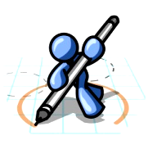

4. Follow the example:

Ex: Daniel may need some help with the activities. **– If you think he may need some help with the activities he has to do, they are probably hard.**

a) Sarah should ask someone to help her with the job.

____________________________________________________________________________________________________________________________________________

b) You must be having trouble with the new tasks.

____________________________________________________________________________________________________________________________________________

c) The students might need assistance with the calculations.

____________________________________________________________________________________________________________________________________________

d) Mr. Jab can finish the maintenance by himself.

____________________________________________________________________________________________________________________________________________

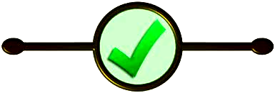

5. Follow the example:

Ex: (I) **– I should focus on what I can do instead of worrying about what I might have trouble doing.**

ORAL PRACTICE: **personal pronouns**

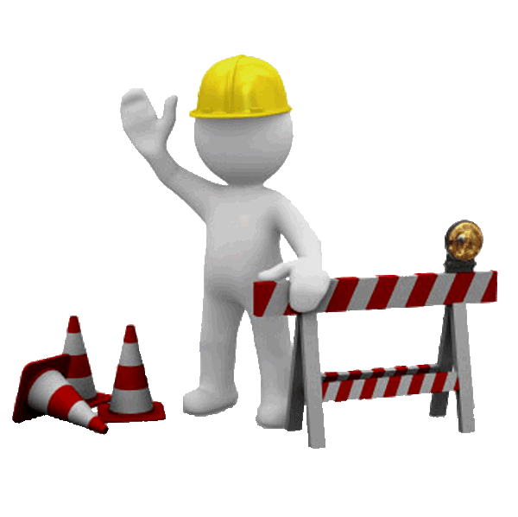

6. What do you think you should do more?

______________________________________________________________________

7. Who do you think might forget about your birthday?

______________________________________________________________________

8. Which TV show do you think may be appropriate for kids?

______________________________________________________________________

9. How can you improve your English skills?

______________________________________________________________________

10. What do you think must be wrong with the government of the country?

______________________________________________________________________